Sprint 1 - Endurance Design Document

November 10, 2019Table of Contents

1. Executive Summary 3

1.1 Project Overview 3

1.2 Purpose and Scope of this Specification 3

2. Product/Service Description 3

2.1 Product Context 3

2.2 User Characteristics 3

2.3 Assumptions 3

2.4 Constraints 4

2.5 Dependencies 4

3. Requirements 4

3.1 Functional Requirements 4

3.2 Security 5

3.2.1 Protection 5

3.2.2 Authorization and Authentication 5

3.3 Portability 5

4. Requirements Confirmation/Stakeholder sign-off 5

5. System Design 5

5.1 Algorithm 5

5.2 System Flow 6

5.3 Software 6

5.4 Hardware 7

5.5 Test Plan 7

5.6 Task List/Gantt Chart 9

5.7 Staffing Plan 10

# Executive Summary

## Project Overview

* The basis of this project is for the students to properly engage in and work on block code to further operate a Sphero robot. The students will all work together in finding out how to solve the endurance portion of the Robotics Project and get the robot to follow the intended specifications. At the end of the project the students will have developed skills that will enable them to move forward with the next two parts of the Robotics project.

## Purpose and Scope of this Specification

In scope

* The purpose of this project is to create an application that will enable the Sphero SPRK+ to move along a rectangular box while switching lights and speaking. This application will give students an introduction to programming in sphero.

Out of Scope

* This application is part one of three in the robotics project. This introduction will give students time to learn the tools in the programming language needed to complete more complex programs.

# Product/Service Description

## Product Context

* This program will relate to the other programs necessary to complete the Robotics Triathlon. This program is independent for Sprint 1 but will join two other independent programs to complete all the tasks in the Triathlon. It is interfaced with phones and computers. The diagram below shows how the Sprints are all independent yet interconnected by the Triathlon.

Robot Triathlon

Sprint 1

Sprint 2

Sprint 3

## User Characteristics

Some of the people that may be using this product include:

* Students
* Teacher / Professor
* Sphero technician
* People that have experience using Sphero and block code
* Classmates who are comparing codes

## Assumptions

* User has access to a Sphero SPRK+.
* User has downloaded and access to Sphero application.
* User has access to classroom for robot testing
* User has access to computer to work on Ghant chart and SDD
* User has access to stay after class to work on the project
* User uses time wisely to finish project on time

## Constraints

* Must have enough computer space to store and run the program
* Must be programmed in Sphero
* A device that lacks Bluetooth capability
* Not enough space to effectively test and execute programs
* Group must be able to organize meetings after class time
* Must complete all required documents

## Dependencies

* This new product will require the SPRK+ to follow the track around the classroom
* The robot must complete all listed requirements
* Groups must be able to effectively communicate
* The group must be able to meet to go over the project and discuss what needs to be completed
* The group must come together in order to solve the problem and figure out how to get the robot to follow the correct code to follow the track around the classroom.

# Requirements

## Functional Requirements

| Req# | Requirement | Comments | Priority | Date Reviewed | SME Reviewed / Approved |
| --- | --- | --- | --- | --- | --- |
| ENDUR_01 | start with a green light and speak ‘ready, set, go’ | Not high priority because of simplicity | 3/10 | 11/03/21 | Approved |
| ENDUR_02 | Be able to move along the long side of the rectangle and stop on corner | If we can get it to move across one without failure, we can do the same for the other | 10/10 | 11/03/21 | Approved |
| ENDUR_03 | Turn 90 degrees | Simple | 1/10 | 11/03/21 | Approved |
| ENDUR_04 | Be able to move along the short side of the rectangle and stop on corner | Same rationale as the long side | 10/10 | 11/03/21 | Approved |
| ENDUR_05 | Turn 90 degrees |  | 1/10 | 11/03/21 | Approved |
| ENDUR_06 | Move along long side of rectangle and stop on corner | Major part of program but low priority because this should reuse data already found | 4/10 | 11/03/21 | Approved |
| ENDUR_07 | Turn 90 degrees |  | 1/10 | 11/03/21 | Approved |
| ENDUR_08 | Move along the short side of the rectangle and stop on corner | Same rational as long side | 4/10 | 11/03/21 | Approved |
| ENDUR_09 | Change light to red and speak “I am done and I need water” | Simple | 3/10 | 11/03/21 | Approved |

## Security

### Protection

* Program is password protected by group members devices

### Authorization and Authentication

* Program is privately shared by group members and validated in person

## Portability

* This project is highly portable because:
* The use of laptops and phones to write and run code enables work to be done basically anywhere
* The application and code is accessible and executable across multiple operating systems
* No internet access is necessary to complete this project
* The SPRK+ is highly portable due to its size
* SPRK+ could be run in almost any indoor environment

# Requirements Confirmation/Stakeholder sign-off

Include documentation of the approval or confirmation of the requirements here. For example:

|  |  |  |
| --- | --- | --- |
| Meeting Date | Attendees (name and role) | Comments |
| 11/03/21 | Julia (leader), Jolie(programmer), and Ryan(recorder) | confirmed all |

# System Design

## Algorithm

1. Have SPRK+ change light to green and speak “ready, set, go”
2. Move along longer side of rectangle in a straight line, stop on the corner
3. Turn 90 degrees
4. Move along shorter side of rectangle in a straight line, stop on the corner
5. Turn 90 degrees
6. Move along longer side of rectangle in a straight line, stop on the corner
7. Turn 90 degrees
8. Move along shorter side of rectangle in a straight line, stop on the corner
9. Change light to red and speak “I am done and I need water”

## System Flow



## Software

Our robot was programmed in Sphero using block code. Below is an image of our sprint 1 block code program along with the sensory data collected after executing the program. The software platform that was used to develop this robotic application was Sphero. This is an online application which enables users to use block code to test out how the robot follows the track around the classroom. This user-friendly program allows the users to simply drag and drop block code and test the code in a less complicated way in comparison to other programming languages. The Sphero application enables the user to understand the basics of programming easily while accomplishing whatever task is at hand. For example, we were able to change the color of the SPRK+’s light by simply using a color wheel; however, if we used a different programming language, we might have had to spend more time trying to figure out the hexadecimal value for the color we needed to use.

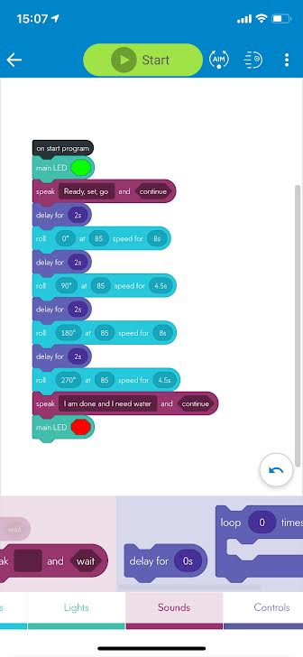 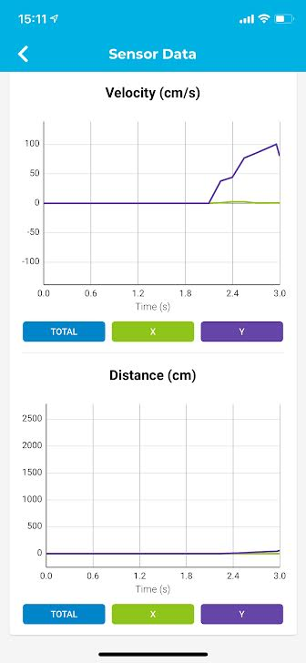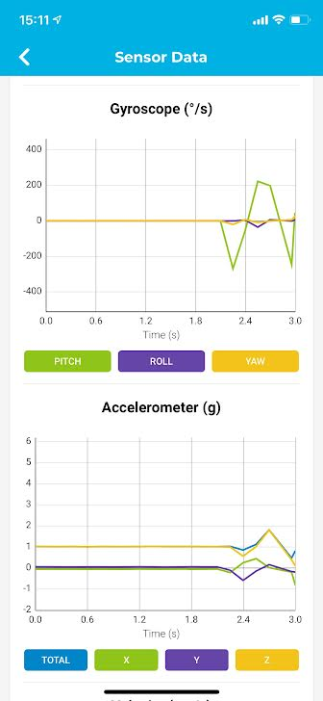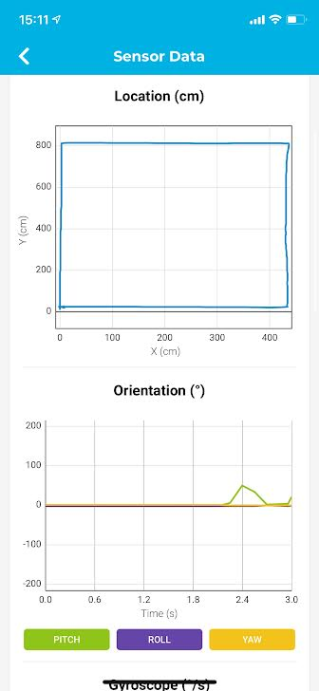

## Hardware

The hardware that we used to undergo this Robotics project was our cell phones or computers. The hardware makes the software an easy-to-use application and helps with the overall programming of the block code. We found that using the computer to code was easier to navigate, but using the phone allowed a more accurate aiming of the SPRK+ because we could move the dial used to aim more precisely. The computer program made this project successful with developing, testing and finalizing the code. We used Sphero SPRK+ to execute our code. We used a cellphone to record the robot video during our demonstration.

## Test Plan

| **Reason for Test Case** | **Test Date** | **Expected Output** | **Observed Output** | **Staff Name** | **Pass/Fail** |
| --- | --- | --- | --- | --- | --- |
| Make sure light changes to green and robot speaks “Ready, set, go” | 11-3-21 | Light change to green and robot speak “ready, set, go” | Light changes to green and robot speak “ready, set, go” | All staff | Pass |
| Have SPRK+ run along the long side of the rectangle to determine speed and time needed | 11-3-21 | Observe the SPRK+ move quickly, yet steadily along the long side of the rectangle | SPRK+ moved too quickly along the side, causing it to run significantly off course | All staff | Fail |
| Have SPRK+ run along the long side of the rectangle to determine speed and time needed | 11-3-21 | Observe the SPRK+ move quickly, yet steadily along the long side of the rectangle | SPRK+ moved at a moderate pace along the line without losing control | All staff | Pass |
| Have SPRK+ run along the long side of the rectangle to determine the time needed | 11-3-2021 | Observe the SPRK+ follow the entire side of the rectangle and stop on its edge | SPRK+ was in motion for too long and did not stop on the edge | All staff | Fail |
| Have SPRK+ run along the long side of the rectangle to determine the time needed | 11-3-2021 | Observe the SPRK+ follow the entire side of the rectangle and stop on its edge | SPRK+ was not in motion long enough and stopped before the edge | All staff | Fail |
| Have SPRK+ run along the long side of the rectangle to determine the time needed | 11-3-2021 | Observe the SPRK+ follow the entire side of the rectangle and stop on its edge | SPRK+ moved along the edge of the rectangle and stopped on its edge | All staff | Pass |
| SPRK+ Turns 90 degrees to face short side of rectangle | 11-3-2021 | SPRK+ turns towards the short rectangle and | SPRK+ turned 90 degrees effectively | All staff | Pass |
| Have SPRK+ run along the short side of the rectangle using the same speed as used previously | 11-9-2021 | SPRK+ moving along the short side of the triangle and stops on the corner | SPRK+ stopped short of the corner | Jolie and Julia | Fail |
| Have SPRK+ run along the short side of the rectangle using the same speed as used previously | 11-9-2021 | SPRK+ moving along the short side of the triangle and stops on the corner | SPRK+ completed the short side and stopped on the corner | Jolie and Julia | Pass |
| Reuse the code for long and short side to complete the whole rectangle | 11-9-2021 | SPRK+ to move along the entirety of the rectangle, stopping at each edge to turn 90 degrees | Completed the rectangle, but the aim of the SPRK+ was not aligned correctly | Jolie and Julia | Fail |
| Reuse the code for long and short side to complete the whole rectangle and correctly aim the SPRK | 11-9-2021 | SPRK+ to move along the entirety of the rectangle, stopping at each edge to turn 90 degrees | Completed the rectangle | Jolie and Julia | Pass |
| Change light color to red and speak “I am done and I need water” | 11-9-2021 | Light change to red and robot speak “I am done and I need water” | Light changed to red, and robot speak “I am done and I need water” | Jolie and Julia | Pass |

## Task List/Gantt Chart

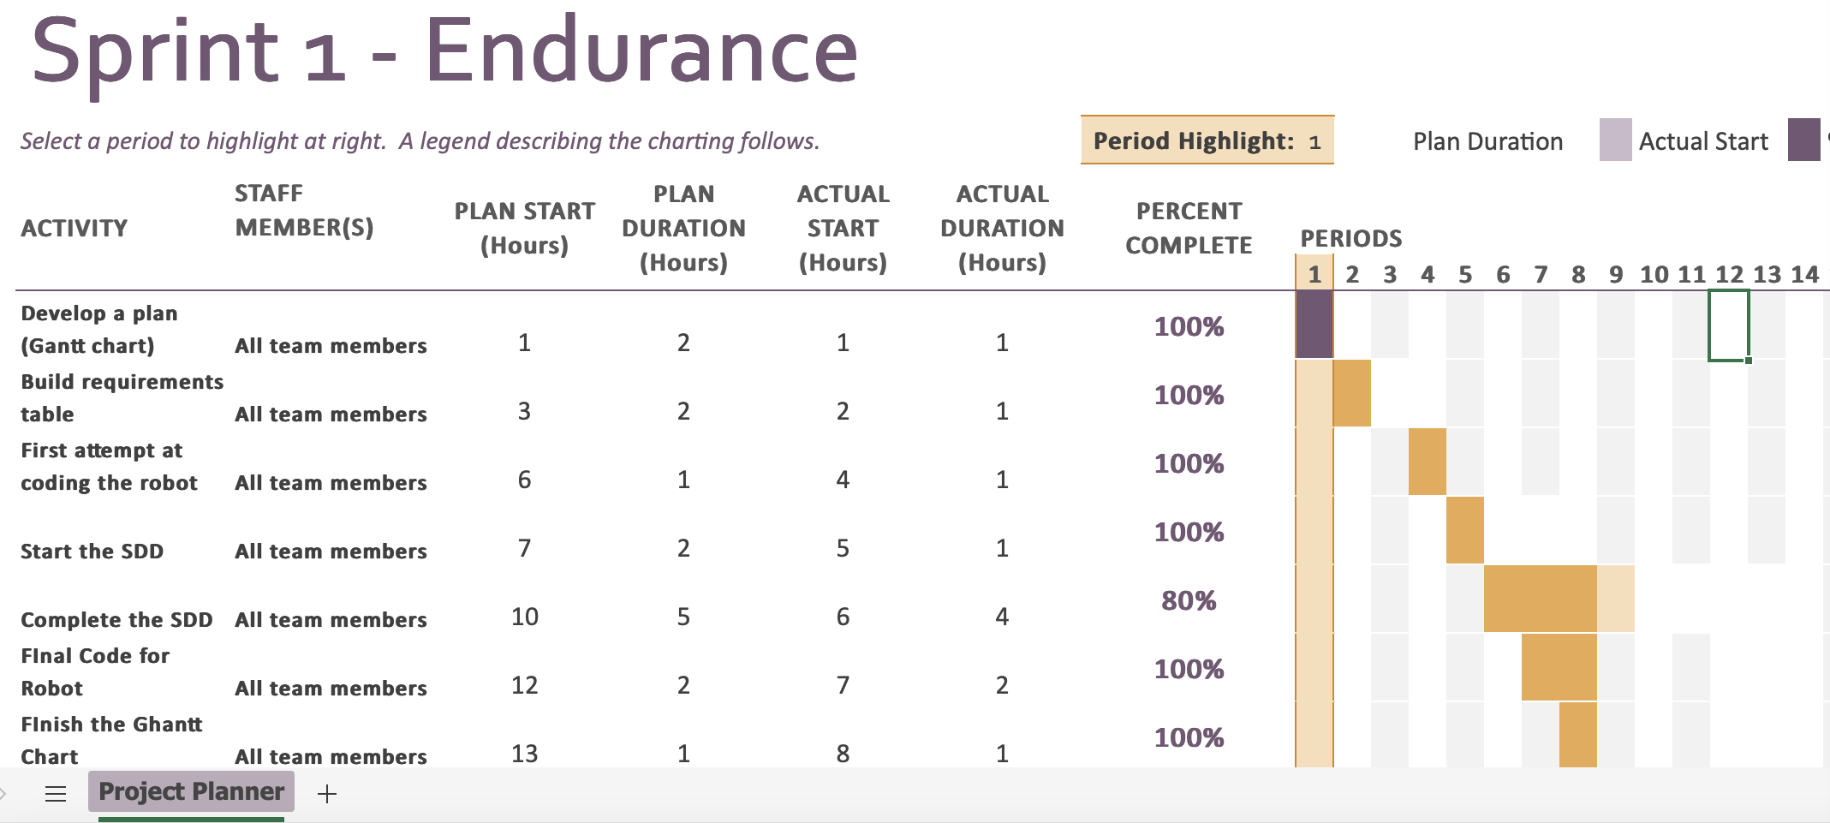

## Staffing Plan

| Name | Role | Responsibility | Reports To |
| --- | --- | --- | --- |
| Ryan | Recorder | Organizes Gantt chart, SDD | Julia |
| Jolie | Programmer | Runs block code. Oversees the robot video and flowchart | Julia |
| Julia | Leader | Manages GitHub repository, SDD, ensures all parts of project are completed | Julia |